**VISVESVARAYA TECHNOLOGICAL UNIVERSITY**

BELGAUM – 590014



A CG LAB (17CSL68) SYNOPSIS OF MINI PROJECT ON

“AEROPLANE CRASH”

***Submitted in partial fulfillment of the requirement of 6th semester***

**BACHELOR OF ENGINEERING IN COMPUTER SCIENCE AND ENGINEERING BY**

**ROSHINI P 1KN17CS070**

**MERCY RABECAL P 1KN17CS052**

***UNDER THE GUIDANCE OF***

**Ms.AMEENA ANJUM, Mrs.AMBIKA.M.ALGUD, Mr.MOHAMMAD ZIAULLA**

Asst. Prof, Dept of CSE Asst. Prof, Dept of CSE Asst.Prof,Dept of CSE



**K.N.S INSTITUTE OF TECHNOLOGY**

**Thirumenahalli, Yelahanka, Bangalore – 560064**

**INTRODUCTION TO COMPUTER GRAPHICS**

Computer graphics started with the display of data on hardcopy plotters and Cathode Ray Tube (CRT) screens soon after the Introduction of computers themselves. It has grown to include the Creation, Storage and Manipulation of Models and Images of objects. These models come from a diverse and expanding set of fields, and include physical, mathematical, engineering, architectural and even conceptual structures, natural phenomenon and so on. Computer graphics today is largely interactive: the user controls the contents, structure, and appearance of objects and of their displayed images by using input devices, such as a keyboard, mouse, or touch-sensitive panel on the screen. Because of the close relationship between the input devices and the display, the handling of such devices is included in the study of computer graphics.

**USES OF COMPUTER GRAPHICS:**

Computer graphics is used in many different areas of industry, business, government, education, entertainment etc.

* **User Interfaces**

Word-processing, spreadsheet and desktop-publishing programs are typical applications of such user-interface techniques.

* **Interactive Plotting in Business, Science and Technology**

The common use of graphics is to create 2D and 3D graphs of mathematical, physical and economic functions, histograms, and bar and pie charts.

* **Computer Aided Drafting and Design (CAD)**

In CAD, interactive graphics is used to design components and systems of mechanical, electrical and electronic devices including structures such as buildings, automobile bodies, aero planes, ship hulls etc.

* **Simulation and Animation for Scientific Visualization and Entertainment**

Computer-produced animated movies are becoming increasing popular for scientific and engineering visualization. Cartoon characters will increasingly be modeled in the computer as 3D shape descriptions whose movements are controlled by computer commands.

* **2D Graphics**

These editors are used to draw 2D pictures (line, rectangle, circle and ellipse) alter those with operations like cut, copy and paste. These may also support features like translation, rotation etc.

* **3D Graphics**

These editors are used to draw 3D pictures (line, rectangle, circle and ellipse).These may also support features like translation, rotation etc.

**INTRODUCTION TO OPENGL**

OpenGL is a software interface to graphics hardware. This interface consists of about 150 distinct commands that you use to specify the objects and operations needed to produce interactive three- dimensional applications.

OpenGL is designed as a streamlined, hardware-independent interface to be implemented on many different hardware platforms. To achieve these qualities, no commands for performing windowing tasks or obtaining user input are included in OpenGL; instead, you must work through whatever windowing system controls the particular hardware you're using. Similarly, OpenGL doesn't provide high-level commands for describing models of three-dimensional objects. Such commands might allow you to specify relatively complicated shapes such as automobiles, parts of the body, airplanes, or molecules. With OpenGL, you must build up your desired model from a small set of *geometric primitives* - points, lines, and polygons.

A sophisticated library that provides these features could certainly be built on top of OpenGL. The OpenGL Utility Library (GLU) provides many of the modeling features, such as quadric surfaces and NURBS (Non-Uniform Rational B-Splines) curves and surfaces. GLU is a standard part of every OpenGL implementation. Also, there is a higher-level, object-oriented toolkit, Open Inventor, which is built atop OpenGL, and is available separately for many implementations of OpenGL.

OpenGL provides a set of commands to render a three dimensional scene. OpenGL is a hardware- and system-independent interface. An OpenGL-application will work on every platform, as long as there is an installed GLUT library.

GLUT is a complete API written by Mark Kilgard which allows us to create windows and render the 2D or 3D scenes. It exists for several platforms, that means that a program which uses GLUT can be compiled on many platforms without (or at least with very few) changes in the code.

# ABSTRACT

The main aim of Aeroplane Crash Computer Graphics Mini Project is to illustrate the concepts and usage of pre-built functions in OpenGL.It shows how an aeroplane is crashed on to a building**.**

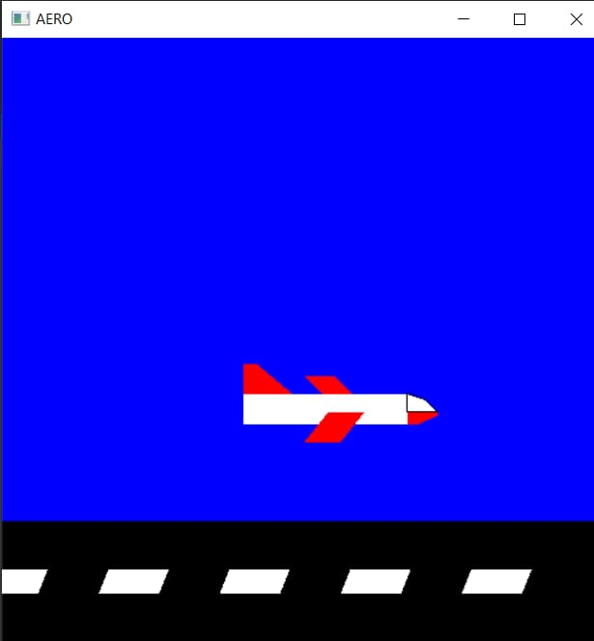

FIGURE:AEROPLANE

**INTRODUCTION**

The main goal of the project is to represent the concepts learned in the OpenGL. The demolition of a building by aeroplane crash. The objects are building,aeroplane and road.The object aeroplane has the movement and the other objects are stationary.when the aeroplane starts moving from the run way and starts flying on the sky suddenly there is a building in the middle of the sky the aeroplane crashes the building.OpenGL is an intermediate between the user and the hardware. OpenGL is an application programming interface used to render 2D or 3D objects. By using OpenGL API we can create graphical videos, games, animation and various other application.

**SYSTEM REQUIREMENTS**

System requirements are intended to communicate in precise way, the functions that the system must provide. To reduce ambiguity, they may be written in a structured form of natural language supplemented by tables and system models.

**MINIMUM HARDWARE REQUIREMENTS:**

The physical components required are:

* Processor - Pentium Pro
* Memory - 128MB RAM
* 40GB Hard Disk Drive

**MINIMUM** **SOFTWARE REQUIREMENTS:**

The software used in building this program are as specified:-

* Operating system –Windows (XP, Vista,7), Linux(Ubuntu 10.4)
* Tools: Microsoft Visual C++ 2008
* Graphics Library – glut. h
* OpenGL 2.0

**REFERENCES**

##### Interactive Computer Graphics – Edward Angel

* + Official OPENGL Documentation at [https://www.**opengl**.org/**documentation**/](https://www.opengl.org/documentation/)

##### OpenGL Programming Guide: The Official Guide to Learning OpenGL- Dave Shreiner.